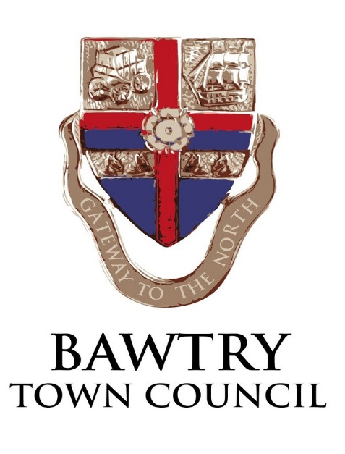

VACANCY – BOOKINGS CLERK

Bawtry Town Council is looking to recruit an enthusiastic and reliable person to carry out the duties of Bookings Clerk for the New Hall, Station Road Bawtry.

Candidates should have excellent interpersonal skills, be computer literate and have some accounting knowledge. They should be able to work as part of a small team, yet also be confident working on their own initiative. Previous experience in the public sector would be helpful, although not essential and training where required will be provided.

The Town Council owns a number of facilities and green spaces including the New Hall. This is a new role reflecting the Council’s management of the hall from 1st May 2019

The successful candidate will be confident and enjoy dealing with members of the public, as part of the local community. The post includes responsibility for public hire arrangements and some day to day management tasks.

Flexibility of working may be required to cater for events.

The work is primarily based from home.

This is a part-time role for 7 hours per week Monday - Friday although weekend work may occasionally be required to cater to hirers needs.

The starting salary is National Joint Council LC1 Point 8 Salary Scale (£19,554) pro rata.
The application form and job description are available on the Town Council website at www.bawtrytowncouncil.com.or via contacting the town clerk (details below).

Completed applications should be returned by 5pm on Friday 26th April 2019 for the attention of Angela Harrison, Clerk to the Council, PO Box 368 Worksop, S81 8GA or emailed to bawtrytowncouncil@gmail.com

If you would like an informal chat about the job please telephone Angela Harrison on 07494 893954

