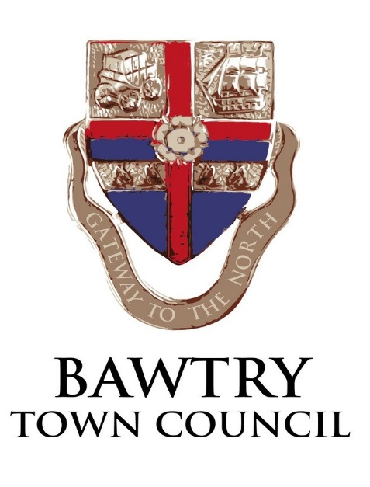

VACANCY –New Hall Caretaker

Bawtry Town Council is looking to recruit an enthusiastic and reliable person to carry out the duties of Caretaker for the New Hall, Station Road Bawtry.

Candidates should have excellent interpersonal skills and should be able to work as part of a small team, yet also be confident working on their own initiative. Previous experience in caretaking/managing a building is essential although training where required will be provided.

The Town Council owns a number of facilities and green spaces including the New Hall. This is a new role reflecting the Council’s management of the hall from 1st May 2019

The successful candidate will be confident and enjoy dealing with members of the public, as part of the local community. The post includes responsibility for security and servicing of the building with some day to day management tasks.

Flexibility of working may be required to cater for events including weekends and evenings.

The work is based at the New Hall, Station Road Bawtry.

This is a part-time role for 10 hours per week Monday – Sunday.

The starting salary is National Joint Council LC1) Joint 7 Salary Scale (£19,171) pro rata (£9.96 per hour).
The job description is available on the Town Council website at www.bawtrytowncouncil.com. or by contacting the town clerk (details below)

To apply please send your C.V, or a summary of your relevant experience, to Angela Harrison, Town Clerk, PO Box 368 Worksop, S81 8GA or by email to bawtrytowncouncil@gmail.com by 26th April 2019

If you would like an informal chat about the job please telephone Angela Harrison on 07494 893954

