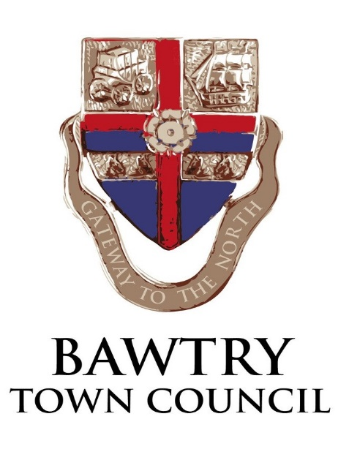

Bawtry Town Council Market Hill Car Park, Bawtry, Doncaster

Invitation to submit a quotation for the management function on behalf of the Town Council

Bawtry Town Council invites suitably qualified companies who are either members of the British Parking Association (BPA) or International Parking Community (IPC) to submit their proposal for the management of their Market Hill surface level ‘pay & display’ car park to be operative as from May 2021. The land on which the car park is situated is privately owned (by the Town Council) and has a Traffic Regulation Order (TRO) in place.

This document together with the proposal of the successful company will form the basis of a legal agreement between ourselves.

The new parking layout is shown on the attached plan but it is anticipated that the existing layout may remain in place for the southern side until 2022 when resurfacing works for that section are currently planned and the re-lining will take place. Although both sides of the car park have ‘one way’ traffic northbound, there is not a single defined entrance as, currently, for some parking spaces vehicles necessarily enter and egress from the High Street.

The total number of parking spaces in the new layout is 108 with 75 being on the southern side and 33 on the northern side. There will be 2 ticket machines on the southern side and 1 machine on the northern side. The machines will be newly provided type that, as well as allowing cash payment, will enable payment by card and, hopefully, by mobile phone.

A service provision agreement will be entered into that will be ongoing and subject to an annual review.

The current charging regime is 365 days a year during the hours of 08:00 to 22:00 hrs. The Town Council is yet to consider its new charging regime so for the purposes of your proposal, the above days/times are to be assumed and your price submitted on that basis. Additionally, we would require an indication of any potential price reductions for the below listed alternative charging days/hours if the Town Council decided to implement any of these changes:

Price reductions are to be indicated, individually, for the following:
1) removing Sundays and Bank Holidays from the charging hours
2) reducing the charging hours from 22:00 hrs to 20:00 hrs, and
3) reducing the charging hours from 22:00 hrs to 18:00 hrs

Fixed price quotations are required in accordance with the requirements of this invitation.

The successful company will be responsible for administering recruitment, selection, appointment and disciplinary control of all staff so as to ensure the service level compliance for all the work detailed in this invitation. The company will also be responsible for the organisational arrangements of its staff and ensure that they carry out their duties in a courteous manner with due regard to the needs and safety of staff, residents, visitors and members of the public.

The company will provide enforcement patrols for the car park with fully qualified and experienced Civil Enforcement Officers (CEO’s) and provide appropriate management of all staff.
The car park will be patrolled for a minimum of 1 visit per day for a duration of at least 1 hour per visit on an ‘ad hoc’ basis so as not to establish a set pattern of daily visits. An occasional 2 visits per day would be expected to help achieve this situation (say at least 2 times per month). Particular attention should be given to evenings and weekends being part of the required attendance situation.
Again, as an option, a price should also be provided for a scenario of a minimum of 2 visits per day and an occasional 3 visits per day, with the same duration of visits as indicated above.
The Town Council does not have any preference for permanent presence of CEO’s but if the proposal considers this would be more beneficial for the Town Council then this may be considered to be acceptable. However, in this situation the company will need to locate its own accommodation and facilities which will not be allowed to be situated within the car parking area.
At each visit the CEO’s will be required to check that the ‘pay & display’ machines are operational and also check that parking tickets and cashless parking sessions have been purchased in accordance with the traffic order governing the car park.
CEO staff will also be required to report any machine faults to the company’s nominated operative to ensure that the machines are promptly repaired.

The company nominated operative will be required to investigate reported machine faults when they are reported as ‘out of use’, and to keep an electronic log of attendance for such faults. All machines will be re-stocked with required ‘pay & display’ tickets. Any required machine engineer calls (to the third party machine supplier) will also be electronically logged.

Penalty Charge Notices (PCN’s) on behalf of the local authority (Bawtry Town Council) will be processed at nil cost to Bawtry Town Council. The Council does, however, expect that the issue of such PCN’s will not be seen as a source of revenue for the company and the Town Council does not wish to benefit from any penalty charge payments. The intentions of the company in this respect are to be stated in their submission. The company will be required to deal with any correspondence/appeals regarding these matters.

The quoted prices are to include for all necessary management costs, arrangement of any traffic order changes, place ticket orders and undertake any other associated required office and management actions.

The quoted fixed prices are to include for all necessary travel costs and other ancillaries. An agreed inflationary figure will be applied to the tendered prices for the contract start date and prices will be reviewed on an annual basis.

Suggestions for alternative management arrangements are welcomed if the company feels that there is a better and more ‘cost-effective’ solution for the management arrangement that would be more beneficial to the Town Council. The Town Council does, however, not bind itself it take any such suggestions into consideration.

Submissions are to be made to the Town Clerk by 5pm Friday 17 January 2020.either by email to bawtrytowncouncil@gmail.com or to:

Angela Harrison
Bawtry Town Council
c/o The Old Coach House
The Yews
Firbeck
S81 8JW

If you have any queries the Clerk can be contacted on 07758822654

Tenders received after 5pm on 17th January 2019 may not be considered.

Summary of required prices:

Duration/Time | 1 visit per day | 2 visits per day | Permanent presence (if applicable)
7 days/wk/365 days per year | £Sum | £Sum | £Sum
Potential option cost reductions
1) Removing Sunday & Bank Holiday charging | £Sum reduction | £Sum reduction | £Sum reduction
2) Reducing charging hours from 22:00 to 20:00 hrs | £Sum reduction | £Sum reduction | £Sum reduction
3) Reducing charging hours from 22:00 to 18:00 hrs | £Sum reduction | £Sum reduction | £Sum reduction

