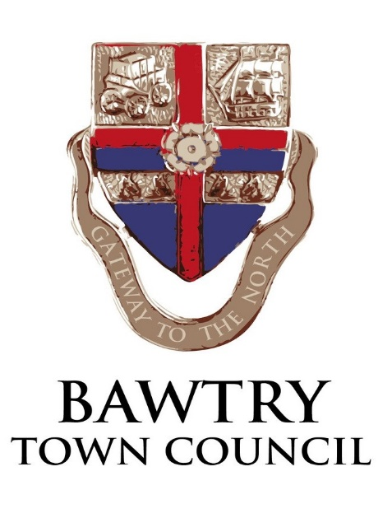
BAWTRY NEW HALL

EMERGENCY PROCEDURES

IN THE EVENT OF FIRE
Leave the hall quickly and calmly via the nearest exit.
If it is safe to do so, extinguishers are available to deal with minor incidents.
If in doubt, call 999 and ask for the fire brigade.

The following information will be requested:
Service required: Fire
Location: The New Hall, Station Road (off Peaks Croft), Bawtry, Doncaster, DN10 6PU

FIRST AID / ACCIDENTS
There is a first aid box on the worktop in the bar area together with the accident report book.
Doncaster Royal Infirmary or Bassetlaw District Hospital are the nearest hospitals

DONCASTER ROYAL INFIRMARY
Doncaster Royal Infirmary Bassetlaw District General Hospital
Armthorpe Road Kilton Hill
Doncaster Worksop
South Yorkshire S81 0BD
DN2 5LT
01302 366666 01909 500990

(Both have 24hr Emergency Departments)

DEFIBRILLATORS

Defibrillators are available at The Crown Hotel, Bawtry Library, Mayflower School and Sainsbury’s

REPORTING
If there is an accident or incident of any type, please fill out an Accident Form in the Accident Book located in the bar area and report the incident to the bookings clerk. Depending on the seriousness of the accident a formal report may be required.

