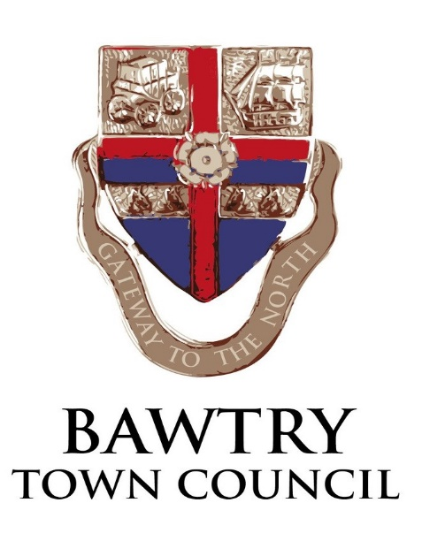
BAWTRY NEW HALL
Terms and Conditions of Hire
Personal Responsibility: For all lettings, there must be one named person (nominated in writing, and approved by the hall booking clerk) who is responsible for the supervision, care and safety of the premises, fabric and contents and the behaviour of all persons using the premises whatever their capacity. This person must ensure that all the following conditions are met:
Appropriate Use: the premises must not be sub-hired or used for any unlawful purpose or in any unlawful way. Users are required to fully disclose their intended use of the hall. The cost of repairing any damage to any part of the property or contents will be charged to the user responsible.
Capacity:
Occupancy Figures Main Hall
Standing Activities-Keep Fit Classes, Dance Classes etc, this can include chairs around the walls of the hall[not blocking exits]
250 persons

Seated Around Tables Activities-ie functions where food/drinks are consumed. Leaving sufficient space between tables to allow safe passageway to exits.
142 persons

Occupancy Figures Small Meeting Room. Based on size of room/Emergency Exits
40 persons

Entrance: Please use the main entrance.
The Hall: Please leave the rooms clean, tidy and secure, or you may incur an extra charge. Tables and chairs should be wiped down and put away tidily as found, floors vacuumed and sticky spills cleaned up. Chairs should be stacked no more than three high and away from radiators.
Kitchen and food preparation: Hirers must observe the food safety regulations. You must inform the booking clerk if you are preparing food for sale. When leaving the hall, please make sure that the cooker, kettle or electrical appliances are turned off at the mains. Floors and surfaces should be cleared of crumbs and spills. Any equipment should be washed and put away. . Users are advised to bring their own tea towels, as they are not provided. Any breakages should be reported and paid for.
NOTE: Bringing onto the premises any propane gas heaters or cooking equipment without the express written permission of the Council is strictly prohibited. The use of lighted candles and combustibles in the building is not allowed without prior permission from the Town Council.
Water: Please check that all taps are turned off before leaving the hall.
Lavatories: Please flush all toilets before leaving.
Lights and Heating: Turn off all lights EXCEPT the outside security light. Please do not adjust the heating controls.
Rubbish: Please take your rubbish with you when you leave.
Cupboards and Equipment: Groups should confine their equipment to any agreed space and keep cupboards tidy. Hall users must NOT use equipment stored by other groups without their direct permission.
Licences: Where the hall is being used to hold regulated entertainment (plays, films, recorded or live music performances, dance performances, indoor sporting events and similar entertainment) you must ensure the activity is covered by the Premises Licence. A copy of the licence may be viewed on request and is located in the entrance area to the main hall in the Notice Board and you are deemed to have had notice of the permitted licensable activities. You are also responsible for obtaining and observing any licenses required by the Performing Rights Society.
Alcohol: You must inform the bookings clerk if alcoholic drinks are to be available at the event. Sale of alcohol may NOT be undertaken Alcohol should NOT be stored or left in the building. Alcohol is NOT to be consumed by persons under the age of 18. Alcohol is NOT to be consumed outside of the building. The hirer accepts responsibility for full compliance with the Licensing Act 2003.
Bouncy Castles:
• must be operated by reputable providers and supply a risk assessment and certificate of insurance to the Town Clerk.
• must be supervised by responsible adults at all times when in use or inflated;
• may not be used by children under 2 years old and restricted to use by age group (age groups 2 to 5, 6 to 12 and over 12 years must not be mixed);
• may not be used outside;
• soft matting must be used to cover hard surfaces adjacent to the front or any open sides to avoid a risk of injury; maximum inflated height 7 feet.
Smoking: Smoking is not permitted anywhere within the premises.
Fire Escape: Please make yourself familiar with the evacuation procedure displayed in the entrance hall.
Exits are marked and should be kept clear at all times. The Fire Brigade must be called to ANY outbreak of fire. Do not tamper with fire extinguishers or discharge them except in emergencies. Should an extinguisher be discharged FOR ANY REASON, please inform the hall booking clerk immediately.

Parking: Please park with consideration for local residents and avoid blocking the highway. Whenever possible use the hall car park and do not park on the pavements or on the grassed areas in front of the hall.
Noise: Please show consideration for our neighbours, especially if you are having a disco. When amplified music is being played in the hall after 19:00 hrs, all windows and doors should remain closed except in the case of doors for entry and exit. Complaints about excessive noise will result in the immediate curtailment of your event. Please keep noise to a minimum after 10.30pm and leave the premises quietly. All events must finish by 11pm, except by prior arrangement with the Council.
Keys: Ensure all the doors and windows are secured before leaving
Bookings: We cannot take bookings from anyone under 18 years of age and all children’s’ parties must be supervised by at least two responsible adults at all times.
Cancellations: Payment in full is required on booking. A full refund will be given if the event is cancelled more than four weeks beforehand. After that time no refund will be given. The Council reserves the right to cancel a hiring in the event of the hall being required for use as a polling station for a Parliamentary or Local Government election or by-election. Any charges already paid will be refunded.
In the event of the hall or any part thereof being rendered unfit for the use for which it has been hired the Council shall not be liable to the Hirer for any resulting loss or damage whatsoever.

Thank you for your help and consideration. Bawtry Town Council
May 2019

