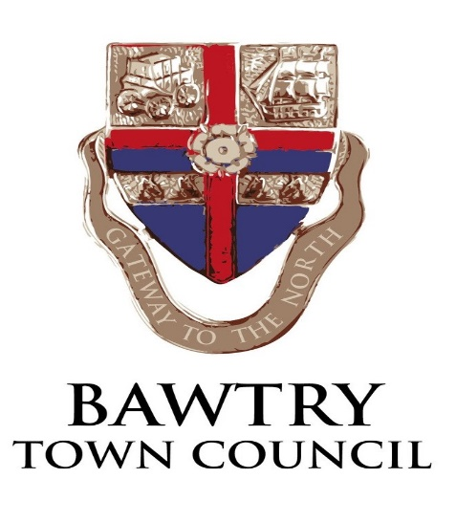
The New Hall- Booking Form
NOTE: Personal information is collected and retained securely for management of hall bookings only. It will not be used for any other purpose, neither will it be passed on to any third party.
BLOCK CAPITALS PLEASE
NAME: (Mr/Mrs/Miss/Ms)………..
ADDRESS: …………
TELEPHONE ………
EMAIL: …...
I wish to book the Whole hall * / main hall* / small meeting room * (*delete as appropriate)
ON (Date): ………........
FOR (Type of function): ……
FROM … (time) TO … time)
(These times should include any “setting-up” and “clearing-up” time required)

Approximate number of persons attending ……

Payment in full £…….... enclosed with this booking form / paid by bank transfer (delete as appropriate) (£15 per hour)
Account Name: | Bawtry Town Council
Sort Code: | 40-19-20
Account Number: | 00133337
NOTE: Bookings are not secured until payment is received.

Is this the first time you have used the hall? YES / NO
I have read and agree to abide by the terms and conditions of hire I accept responsibility for full compliance with the Licensing Act 2003 (if serving alcohol).

COMBINATION ACCESS - Turn black knob anti-clockwise to clear any stored code. Press 2&4 TOGETHER. Press 3, Turn the black knob CLOCKWISE to open

Signature………………………………… Organisation (if applicable)………………….……….

PLEASE PRINT OUT, SIGN AND RETURN FORM TO BOOKING CLERK Post to: Town Clerk, The Old Coach House, The Yews, Firbeck Worksop S81 8JW or email to bawtrytowncouncil@gmail.com

