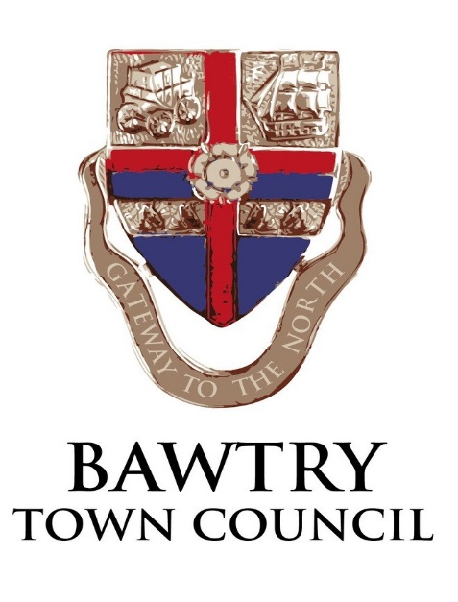
Social Media Comments Policy
Bawtry Town Council encourages debate on its social media channels and recognises that not everyone commenting will always be in agreement with the council. This debate is important for democracy and allows a two way communication process.
The council does operate a moderation system for comments. The majority of comments are allowed on the council’s social media channels, however, there are some exceptions when comments will either be hidden or deleted, these include:
- offensive, malicious, disrespectful comments or those that attack a person’s character (defamatory comments)
- comments that incite hatred based on religion, race, gender, nationality, sexuality or any other personal characteristic
- comments that give any form of personal information including addresses, phone numbers or email addresses
- any spam or third party advertisement
- party political messages or advertisement of political events
- any comments with swear words or language that could cause offense
- any libellous comments or those which break the law – for example illegal activity or copyright
We also reserve the right to hide any posts from malicious or vexatious, persistent commentators, sometimes referred to as ‘trolls’, who deliberately post content to provoke a response.
We also reserve the right to remove any new comments on posts that are more than 6 months old and any comments that are off topic.

Bawtry Town Council responses
The council does its best to read all comments posted on its social media sites and will reply where relevant and appropriate.
Pages are monitored during the working week and responses are posted periodically as required.
Pages are also monitored out of hours for posts that contravene the above.
In general terms, the council will provide responses to questions and will also respond to any factually incorrect information. The council may choose to answer questions individually or in one overall response on posts with a large volume of comments.
Alternatively, it may choose not to reply at all, depending on the situation.
If posts are making a complaint about the council then they will be referred to the formal councils complaints procedure, a dialogue will not be undertaken via social media.
Supplementary questions will be responded to as appropriate but the council may decide to stop responding if the person’s actions start to constitute vexatious behaviour.
Any freedom of information requests will be passed through to the Town Clerk.
The council may choose to reply to commentators ‘offline’ if the situation warrants it, this could be through email or direct message. It may also encourage people to contact the town clerk so their question can be answered fully or may sign-post to another organisation, where relevant.

Banning or removing followers
Bawtry Town Council will remove people from its social media accounts if they continue to flout the guidelines for comments – this includes vexatious commentators. The council will first ask the person to stop causing offensive or posting inappropriate or illegal content.
It will also ban any account that appears to be fake.

