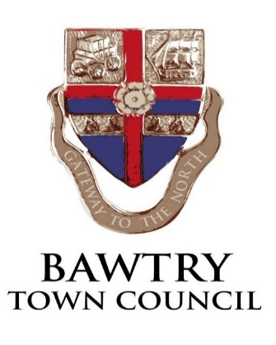

NOTICE OF EXTRAORDINARY TOWN COUNCIL MEETING
at The New Hall, Station Road, Bawtry on
WEDNESDAY 27th March 2024 AT 7.00PM

A. Claypole Chairman 18th March 2024

AGENDA

- RECEIVE APOLOGIES & APPROVE REASONS FOR ABSENCE

- TO RECEIVE DECLARATIONS OF INTEREST

- AGREE CONFIDENTIAL ITEMS

- EXTENDED PUBLIC DISCUSSION PERIOD

- CONSIDER FUTURE OF THE MEMORIAL SPORTS GROUND

- CONSIDER POTENTIAL ACTIONS OF THE COUNCIL
UNDER THE LEASE WITH BARS, INCLUDING RECEIVE LEGAL ADVICE

